# MCAE Automation updated on 08-02

Project saved to below location  
  
[\\10.160.0.47\OpsDataTeam\18. Projects\MCAE](\\\\10.160.0.47\\OpsDataTeam\\18. Projects\\MCAE)  
  
Deployed onto 10.204.200.112 and scheduled to run every 1st day of month at 09:10 AM  
  
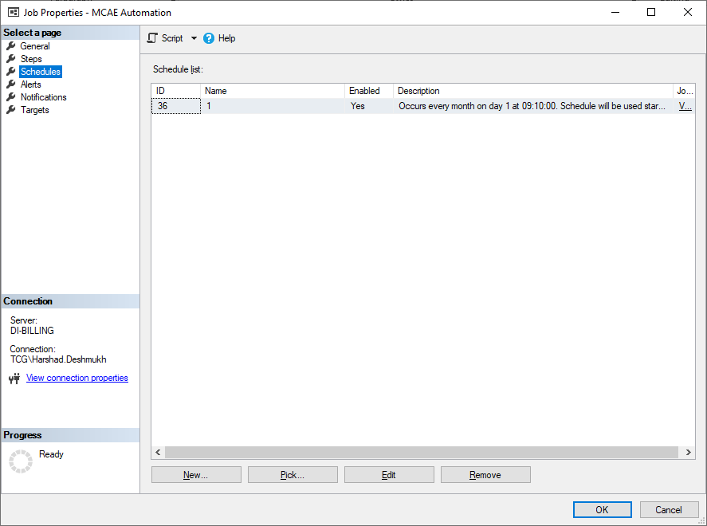  
  
Output file generated at   
  
\\10.160.0.47\PriorityPass\9. Projects\Live Projects\1 - Ops Automation\MCAE Automation